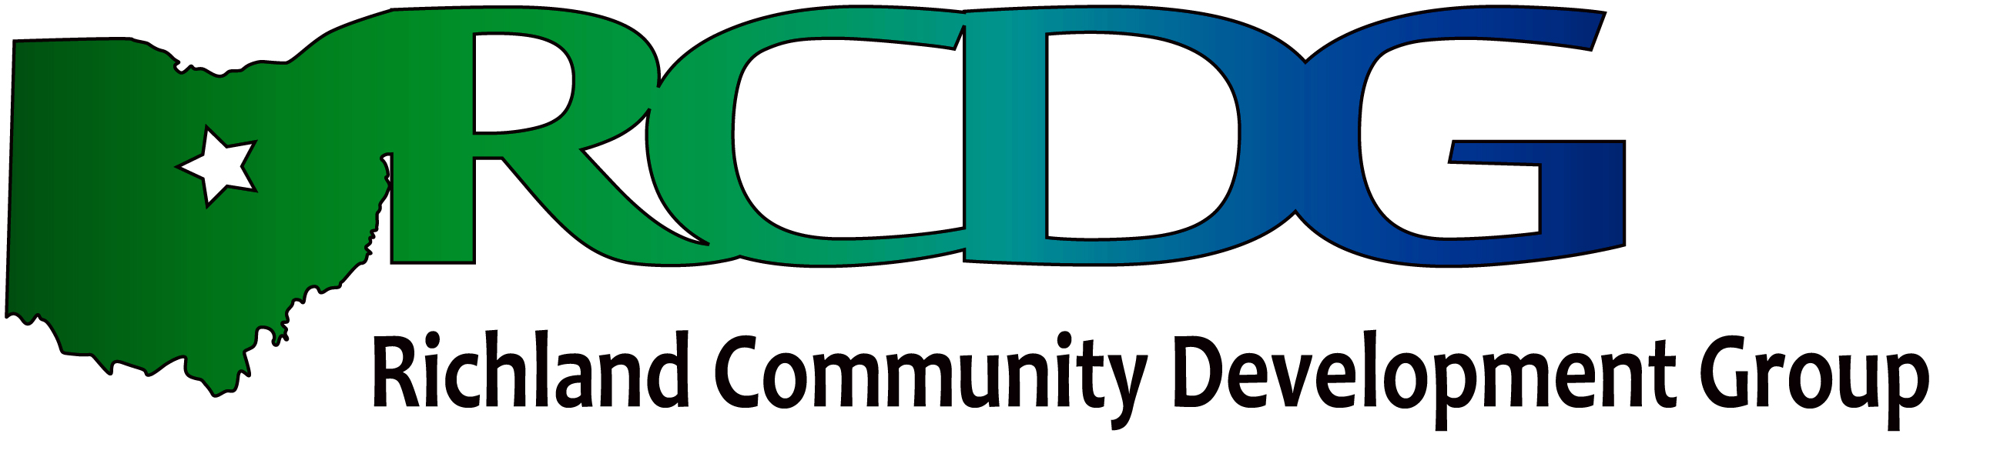

Government Sector Sponsors Second Forum
Focuses on

“How to Get Government Collaboration Opportunities Funded”

The Government Sector of RCDG is holding its Second Forum June 28, 2012. This event will focus on “How to Get Government Collaboration Opportunities Funded.” This Forum will focus on real examples of local governments around Ohio that collaborate to improve services. It will provide information on the Local Government Innovation Fund that was established to provide financial assistance to Ohio political subdivisions for planning and implementing projects that are projected to create more efficient and effective service delivery. This forum is timely in that the Round 3 Applications for grants or loans from this program are due in early September.
The Forum is free and open to all elected officials, fiscal officers, department managers, school officials, and other interested parties. The Presenter will be Thea Walsh Deputy Chief of the Office of Redevelopment at the Ohio Department of Development. The first forum sponsored by this sector had over sixty officials in attendance.

The event will be held at the Springmill Learning Center on Nestor Drive in Mansfield, OH. Registration begins at 8:30am with the presentation from 9:00am until 10:00am. A question and answer period will follow. Coffee, beverages, and snacks provided by Frey Scientific. Anyone interested in more information or in registering for the event should contact Ellen Haring, ekharing@aol.com, 419-756-6694 or Bridget McDaniel, bridget@chooserichland.com, 419-755-7234.

The first forum sponsored by this sector had over sixty officials in attendance so registration is encouraged.

