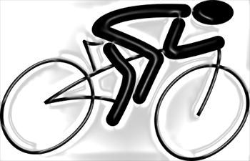

**BIKE-A-PALOOZA**

**BICYCLE SAFETY RODEO**

**PERMISSION SLIP**

***“All minors must have a signed permission slip in order to participate in this event”***

Child’s Name:_________________________________________________________

**PLEASE PRINT CHILD’S NAME LEGIBLY**

I/We assume all risks and hazards incidental to such participation in the Bicycle Safety Rodeo Being sponsored by the City of Mansfield and the Mansfield Division of Police at North Lake Park.

I/We agree to hereby waive, release, absolve, and agree to hold harmless the volunteers, instructors and sponsors involved in the Bicycle Safety Rodeo that my/our child is participating in.

**PHONE NUMBER**

**PLEASE PRINT PARENT OR GUARDIAN NAME**

**DATE**

**PARENT OR GUARDIAN SIGNATURE**